10 | Implementing Frame (Using C++)
Given information:
"Ram is a person living in Nepal. He was born on 15th December of year 1990. He is 6 inch tall and has 75 kg weight. He has a job. He works at 'ABC company' as AI Researcher and earns 1.5 lakhs per month. The company is situated at Kathmandu."
Theory:
Frames are a knowledge representation scheme used in artificial intelligence to represent stereotypical situations or objects. They are similar to classes in object-oriented programming, containing slots (attributes) that can have specific values or default values. Frames can also include procedural attachments, which are procedures or methods associated with a frame.
Key characteristics of Frames:
- Hierarchical Structure: Frames can inherit properties from parent frames.
- Default Values: Slots can have default values that are assumed unless explicitly changed.
- Procedural Attachment: Frames can have associated procedures that are triggered when certain conditions are met.
- Flexible Representation: Frames can represent both declarative and procedural knowledge.
Applications of Frames:
- Natural Language Processing
- Expert Systems
- Object Recognition in Computer Vision
- Knowledge Management Systems
Frames:
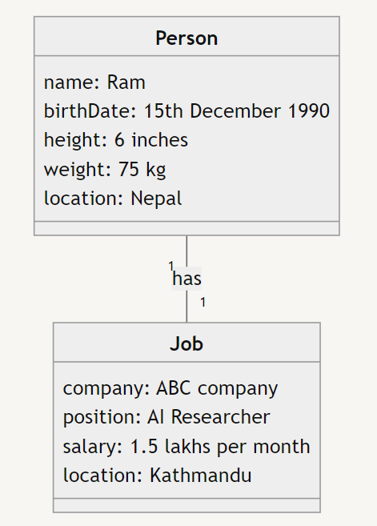
Code:
#include <iostream>
#include <string>

using namespace std;

class Job {
private:
string company;
string position;
double salary;
string location;

public:
Job(const string& comp, const string& pos, double sal, const string& loc)
: company(comp), position(pos), salary(sal), location(loc) {}

void display() const {
cout << "Job Information:" << endl;
cout << "Company: " << company << endl;
cout << "Position: " << position << endl;
cout << "Salary: " << salary << " lakhs per month" << endl;
cout << "Location: " << location << endl;
}
};

class Person {
private:
string name;
string birthDate;
int height;
double weight;
string location;
Job* job;

public:
Person(const string& n, const string& bd, int h, double w, const string& loc)
: name(n), birthDate(bd), height(h), weight(w), location(loc), job(nullptr) {}

~Person() {
delete job;
}

void setJob(const string& comp, const string& pos, double sal, const string& loc) {
job = new Job(comp, pos, sal, loc);
}

void display() const {
cout << "Person Information:" << endl;
cout << "Name: " << name << endl;
cout << "Birth Date: " << birthDate << endl;
cout << "Height: " << height << " inches" << endl;
cout << "Weight: " << weight << " kg" << endl;
cout << "Location: " << location << endl;

if (job) {
cout << endl;
job->display();
}
}
};

int main() {
Person ram("Ram", "15th December 1990", 6, 75, "Nepal");
ram.setJob("ABC company", "AI Researcher", 1.5, "Kathmandu");
ram.display();
return 0;
}

Output:
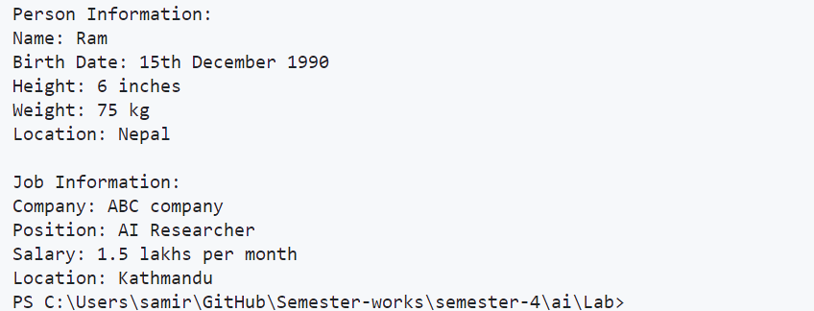

11 | Title: Prolog Basic
About Language (What/ When/ Who/ Why)
Atoms, Variables, Facts and Rules in Prolog
Theory:
What: Prolog (Programming in Logic) is a logic programming language associated with artificial intelligence and computational linguistics.
When: Developed in the 1970s, Prolog has since been used in various applications, particularly in AI research and development.
Who: Prolog was created by Alain Colmerauer and his colleagues, focusing on logical reasoning and symbol manipulation.
Why: It is particularly well-suited for problems involving symbolic reasoning, complex data structures, and natural language processing.
Key characteristics of Prolog:
- Declarative Programming: Programs describe the logical relationships between objects rather than specifying a sequence of steps.
- Unification: The process of making two terms identical by finding a substitution for variables.
- Backtracking: Automatic search mechanism that allows Prolog to explore multiple solutions.
- Pattern Matching: Used for selecting clauses and passing arguments.
Basic Elements of Prolog:
- Atoms: Names starting with a lowercase letter or enclosed in single quotes.
- Variables: Names starting with an uppercase letter or underscore.
- Facts: Express unconditional truths about objects and their relationships.
- Rules: Express conditional knowledge, consisting of a head and a body.
Code:
% Facts
cat(tom).
cat(jerry).
mouse(mickey).

% Rules
animal(X) :- cat(X).
animal(X) :- mouse(X).

% Queries
% ?- cat(tom).
% ?- animal(jerry).
% ?- animal(X).

% Lab information
% Lab No.: 11
% Name: Samir Paudel
% Roll No./Section: 114/D
Output:
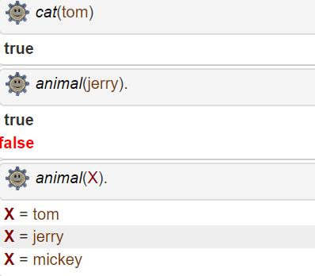

12 | Title: Ancestor program using Prolog
Theory: The ancestor program in Prolog demonstrates the use of recursive rules to define relationships in a family tree. It showcases Prolog's ability to work with complex relationships and perform logical inferences based on given facts and rules.
Key concepts:
- Facts: Direct relationships (parent-child) are defined as facts.
- Rules: Indirect relationships (ancestor) are defined using rules.
- Recursion: The ancestor rule calls itself to find indirect ancestors.
- Queries: Users can ask questions about relationships in the family tree.
Code:
% Facts: parent(Parent, Child)
parent(john, mary).
parent(john, sam).
parent(mary, ann).
parent(mary, bob).
parent(sam, tom).
parent(sam, pam).
% Rules
% X is an ancestor of Y if X is a parent of Y
ancestor(X, Y) :- parent(X, Y).
% X is an ancestor of Y if X is a parent of Z and Z is an ancestor of Y
ancestor(X, Y) :- parent(X, Z), ancestor(Z, Y).
% Queries
% ?- ancestor(john, bob).
% ?- ancestor(john, X).
% ?- ancestor(X, pam).
Output:
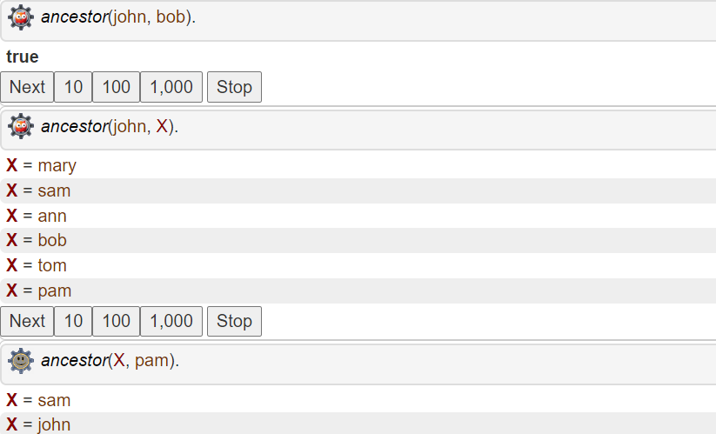

13 | Title: Family relationship (family tree) program using Prolog
Theory:
A family relationship program in Prolog extends the ancestor program by defining various familial relationships such as siblings, grandparents, aunts, and uncles. This program demonstrates Prolog's ability to infer complex relationships based on a set of basic facts and rules.
Key concepts:
- Facts: Basic relationships (parent-child) are defined as facts.
- Rules: More complex relationships are defined using rules.
- Multiple Rules: Some relationships can have multiple definitions.
- Queries: Users can ask about various family relationships.
Code:
% Facts: parent(Parent, Child)
parent(john, mary).
parent(john, sam).
parent(jane, mary).
parent(jane, sam).
parent(mary, ann).
parent(mary, bob).
parent(sam, tom).
parent(sam, pam).

% Rules
father(X, Y) :- parent(X, Y), male(X).
mother(X, Y) :- parent(X, Y), female(X).
sibling(X, Y) :- parent(Z, X), parent(Z, Y), X \\\\= Y.
grandparent(X, Y) :- parent(X, Z), parent(Z, Y).
aunt_uncle(X, Y) :- sibling(X, Z), parent(Z, Y).
cousin(X, Y) :- parent(Z, X), parent(W, Y), sibling(Z, W).

% Additional facts for gender
male(john).
male(sam).
male(bob).
male(tom).
female(jane).
female(mary).
female(ann).
female(pam).

% Queries
% ?- sibling(mary, sam).
% ?- grandparent(john, bob).
% ?- aunt_uncle(X, ann).
% ?- cousin(ann, tom).

% Lab information
% Lab No.: 13
% Name: Samir Paudel
% Roll No./Section: 114/D

Output:
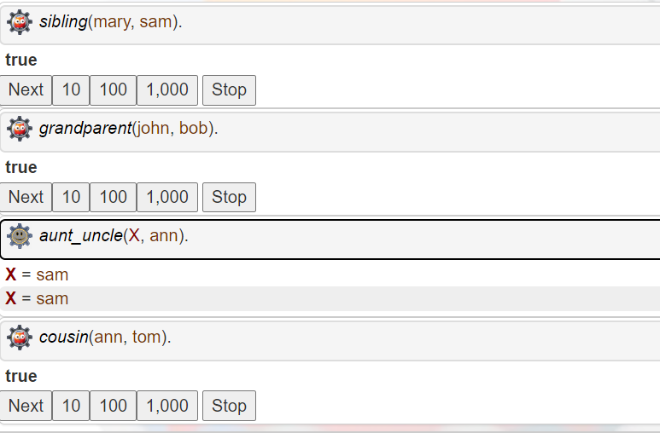

14 | Represent following facts in Semantic Net diagrammatically and also write a program in Prolog to represent the Semantic Net.
Mat1 is a mat
Cat1 is a cat
Tom is a cat.
Bird1 is a bird.
Cat1 sat on Mat1.
Tom caught bird1.
Tom is owned by John.
Tom is ginger in color.
Cats like cream.
The cat sat on the mat.
A cat is a mammal.
A bird is an animal.
All mammals are animals.
Mammals have fur.
Theory:
A Semantic Network is a knowledge representation method used in artificial intelligence to represent relationships between concepts. In Prolog, we can represent a semantic network using facts and rules. This allows us to create a network of interconnected concepts and query the relationships between them.
Key concepts:
- Facts: Represent direct relationships between concepts.
- Rules: Define more complex relationships or inferences.
- Queries: Allow for exploring the semantic network.
- Inheritance: Concepts can inherit properties from their parent concepts.
Semantic Net Diagram:
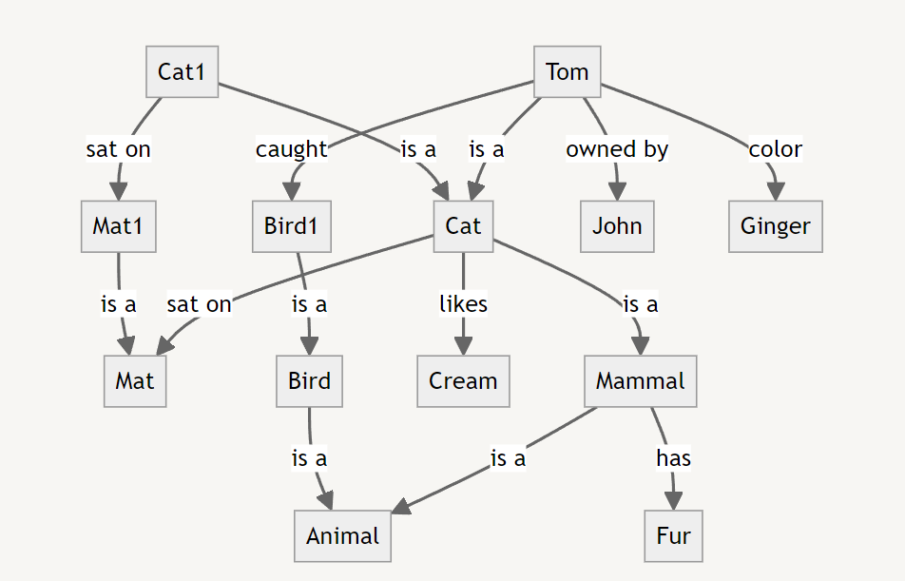
Code:
% Facts
is_a(mat1, mat).
is_a(cat1, cat).
is_a(tom, cat).
is_a(bird1, bird).
sat_on(cat1, mat1).
caught(tom, bird1).
owned_by(tom, john).
color(tom, ginger).
likes(cat, cream).
sat_on(cat, mat).
is_a(cat, mammal).
is_a(bird, animal).
is_a(mammal, animal).
has(mammal, fur).

% Rules
has_property(X, Y) :- is_a(X, Z), has(Z, Y).

Output:
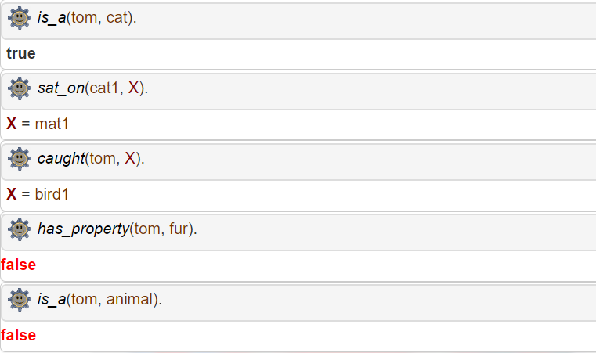

15 | Write a program to demonstrate the working of Naive Bayse classifier by taking a suitable example problem.

Theory:

The Naïve Bayes classifier is a probabilistic machine learning model based on Bayes' Theorem, particularly suited for classification tasks. It's called "naïve" because it assumes that features are independent of each other, which is often not true in real-world scenarios. Despite this, the classifier performs surprisingly well in many applications, such as text classification, spam detection, and sentiment analysis.

Bayes' Theorem
The core of Naïve Baye classifier is Bayes' Theorem, which describes the probability of a hypothesis given the data:
P(H|D)=$\frac{P(D|H).P(H)}{P(D)}$
Where,
- P(H|D) is the probability of the hypothesis HHH(the class) given data DDD(features).
- P(D|H) is the likehood, i.e the probability of data DDD given the hypothesis HHH.
- P(H) is the prior probability of the hypothesis (the class).
- P(D) is the evidence i.e the overall probability of the data.
How the Naïve Bayes Classifier works:
- Training : During the training phase , the model estimates the likelihood and prior probabilities for each class using the training data.
- Prediction: Given a new input (with features), the classifier applies Bayes' Theorem to compute the posterior probability for each class. The class with the highest posterior probability is choosen as the prediction.

Code:

from sklearn.naive_bayes import BernouliNB
from sklearn.preprocessing import LabelEncoder
import numpy as np

data = np.array(
[
["young", "high"],
["young", "low"],
["middle-aged", "low"],
["old", "high"],
["old", "low"],
]
)
target = ["no", "no", "no", "yes", "no"]
le = LabelEncoder()
age = le.fit_transform(data[:, 0])
income = le.fit_transform(data[:, 1])
features = np.vstack((age, income)).T
target_encoded = le.fit_transform(target)
nb = BernoulliNB()
nb.fit(feature, target_encoded)
predictions = nb.predict(features)
accuracy = np.mean(predictions == target_encoded)
print(f"Accuracy: {accuracy * 100:.2f}%")
new_data = np.array([[0, 0]])
predicted = nb.predict(new_data)
predicted_label = le.inverse_transform(predicted)
print(f"Predicted class for new data (young , high income):{predicted_label[0]}")

print("Lab no:15")
print("Name: Samir Paudel")
print("Roll No: 114")
print("Section:D")

Output:
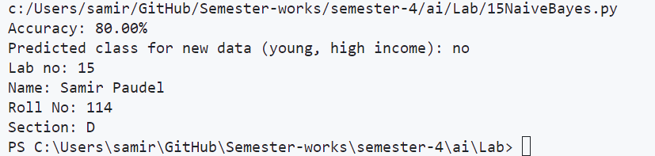

16 | WAP to develop a sample medical expert system capable of diagnosing disease based on the provided symptoms.
Theory:
A medical expert system is an AI-based application that uses a knowledge base of expert medical information to offer diagnoses or treatment recommendations. It simulates the decision-making ability of a human expert in the medical field. These systems typically use if-then rules and can handle uncertainty through various methods like certainty factors or fuzzy logic.
Key components of a Medical Expert System:
- Knowledge Base: Contains domain-specific medical knowledge.
- Inference Engine: Applies logical rules to the knowledge base to deduce new information.
- User Interface: Allows users to input symptoms and receive diagnoses.
- Explanation Facility: Provides reasoning for the system's conclusions.
Code:
class MedicalExpertSystem:
def __init__(self):
self.knowledge_base = {
"fever": ["flu", "covid-19", "malaria"],
"cough": ["flu", "covid-19", "bronchitis"],
"fatigue": ["flu", "covid-19", "anemia"],
"shortness_of_breath": ["covid-19", "asthma", "heart disease"],
"headache": ["flu", "migraine", "stress"],
"rash": ["allergic reaction", "measles", "chickenpox"]
}

def diagnose(self, symptoms):
possible_diseases = set()
for symptom in symptoms:
if symptom in self.knowledge_base:
possible_diseases.update(self.knowledge_base[symptom])

return list(possible_diseases)

# Create the expert system
expert_system = MedicalExpertSystem()

# Get symptoms from user
symptoms = input("Enter symptoms (comma-separated): ").lower().split(',')
symptoms = [s.strip() for s in symptoms]

# Get diagnosis
diagnosis = expert_system.diagnose(symptoms)

print(f"\nBased on the symptoms {', '.join(symptoms)}, possible conditions are:")
for disease in diagnosis:
print(f"- {disease}")

print("\nPlease consult with a medical professional for accurate diagnosis.")

print("\nLab No.: 16")
print("Name: Samir Paudel")
print("Roll No: 114")
print("Section:D")

Output:
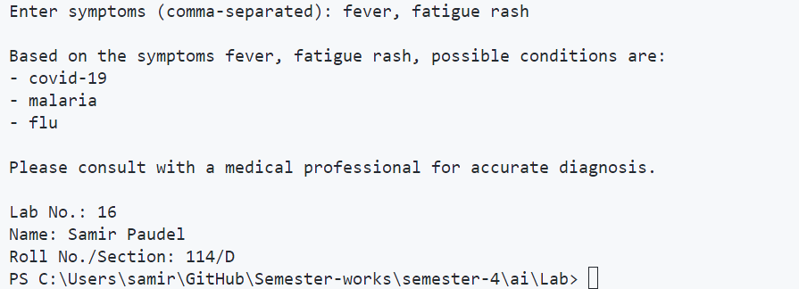

17 | Realization of AND, OR and NOT gates using Artificial Neurons
Theory:

AND,OR and NOT gates are fundamental building blocks of digital circuits, and they can be implemented using artificial neurons. An artificial neuron, also know as a perception, ia a mathematical function that takes inputs, applies weights to them, and produces an output. The output is calculated using an activation function, which determines whether the neuron fires or not based on its inputs.

1.AND Gate:
To realize an AND gate using artificial neurons, we can use two inputs neurons and one output neuron. Each input neuron receives a binary input(either 0 or 1), and the output neuron calculates the AND function of the two inputs using threshold activation function. Specially, the output neuron fires(outputs 1) only if both input neuron fire(output 1), and it does not fire(outputs 0) otherwise. The weights of input neurons can be adjusted to control the sensitive of the AND gate.
2.OR Gate:
To realize an OR gate using artificial neurons, we can use two inputs neurons and one output neuron. Each input neuron receives a binary input(either 0 or 1), and the output neuron calculates the OR function of the two inputs using threshold activation function. Specially, the output neuron fires(outputs 1) if either input neuron fires (outputs 1) or if both input neuron fire(output 1),if neither input neuron fire(outputs 0) otherwise. The weights of the input neurons can be adjusted to control the sensitive of the OR gate.

3.NOT Gate:
To realize an NOT gate using artificial neurons, we can use one input neurons and one output neuron. The input neuron receives a binary input(either 0 or 1), and the output neuron calculates the NOT function of the input using threshold activation function. Specially, the output neuron fires(outputs 1) if the input neuron does not fire(outputs 0), and it does not fire(outputs 0) if input neuron fires(outputs 1). The weight of the input neurons can be adjusted to control the sensitive of the NOT gate.

Code:

import numpy as np
def step_function(x):
return 1 if x >= 0 else 0
class LogicGate:
def __init__(self, weights, bias):
self.weights = weights
self.bias = bias

def predict(self, inputs):
sum_inputs = np.dot(inputs, self.weights) + self.bias
return step_function(sum_inputs)

and_gate = LogicGate(weights=[1, 1], bias=-1.5)
or_gate = LogicGate(weights=[1, 1], bias=-0.5)
not_gate = LogicGate(weights=[-1], bias=0.5)

print("AND Gate:")
print(f"0 AND 0 = {and_gate.predict([0, 0])}")
print(f"0 AND 1 = {and_gate.predict([0, 1])}")
print(f"1 AND 0 = {and_gate.predict([1, 0])}")
print(f"1 AND 1 = {and_gate.predict([1, 1])}")

print("\nOR Gate:")
print(f"0 OR 0 = {or_gate.predict([0, 0])}")
print(f"0 OR 1 = {or_gate.predict([0, 1])}")
print(f"1 OR 0 = {or_gate.predict([1, 0])}")
print(f"1 OR 1 = {or_gate.predict([1, 1])}")

print("\nNOT Gate:")
print(f"NOT 0 = {not_gate.predict([0])}")
print(f"NOT 1 = {not_gate.predict([1])}")

print("\nLab No.: 17")
print("Name: Samir Paudel")
print("Roll No: 114")
print("Section:D")

Output:

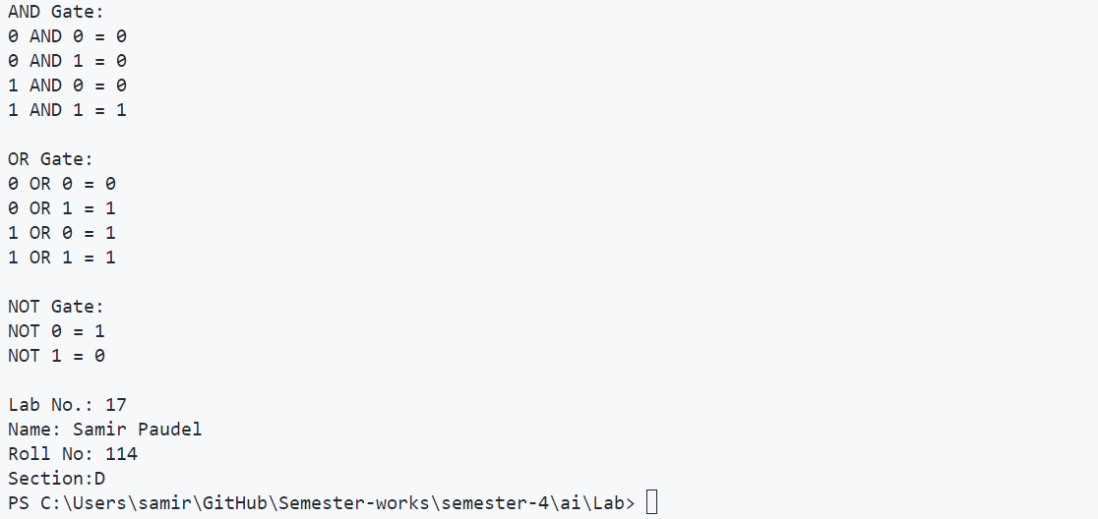

18 |A Simple Example of Back Propagation Learning
Theory:
Backpropagation is a supervised learning algorithm used to train artificial neural networks. It works by calculating the gradient of the loss function with respect to each weight by the chain rule, computing the gradient one layer at a time, iterating backward from the last layer to avoid redundant calculations of intermediate terms in the chain rule.
Key concepts:
- Forward pass: Compute the output of the network given inputs.
- Loss calculation: Measure the error between predicted and actual outputs.
- Backward pass: Compute gradients and update weights to minimize error.
- Learning rate: Controls the step size during optimization.
Code:
import numpy as np
def sigmoid(x):
return 1 / (1 + np.exp(-x))

def sigmoid_derivative(x):
return x * (1 - x)

class NeuralNetwork:
def __init__(self, x, y):
self.input = x
self.weights1 = np.random.rand(self.input.shape[1], 4)
self.weights2 = np.random.rand(4, 1)
self.y = y
self.output = np.zeros(self.y.shape)

def feedforward(self):
self.layer1 = sigmoid(np.dot(self.input, self.weights1))
self.output = sigmoid(np.dot(self.layer1, self.weights2))

def backprop(self):
d_weights2 = np.dot(self.layer1.T, (2*(self.y - self.output) * sigmoid_derivative(self.output)))
d_weights1 = np.dot(self.input.T, (np.dot(2*(self.y - self.output) * sigmoid_derivative(self.output), self.weights2.T) * sigmoid_derivative(self.layer1)))

self.weights1 += d_weights1
self.weights2 += d_weights2

def train(self, iterations):
for _ in range(iterations):
self.feedforward()
self.backprop()

# Example usage
X = np.array([[0,0,1], [0,1,1], [1,0,1], [1,1,1]])
y = np.array([[0], [1], [1], [0]])

nn = NeuralNetwork(X, y)

print("Initial output:")
nn.feedforward()
print(nn.output)

nn.train(10000)

print("\nOutput after training:")
nn.feedforward()
print(nn.output)

print("\nLab No.: 18")
print("Name: Samir Paudel")
print("Roll No: 114")
print("Section:D")

Output:
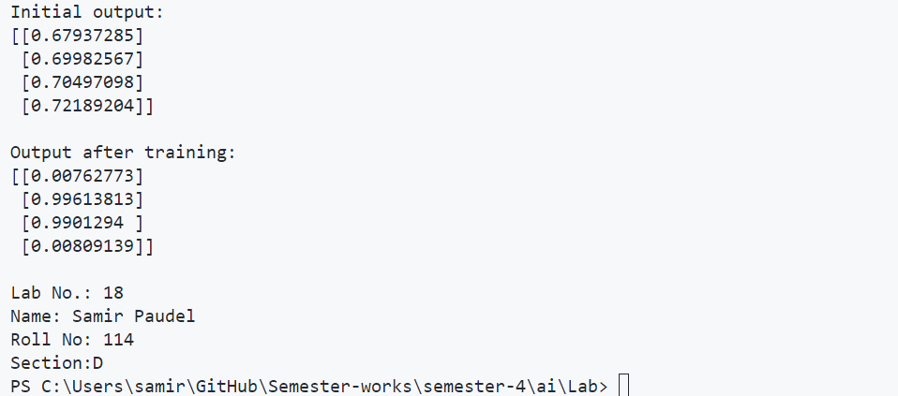

19 | WAP to solve N Queen Problem.
(Problem: To find an arrangement of N queens on a chess board of size N×N, such that no queen can attack any other queens on the board).
Theory:
The N-Queens problem is a classic problem in computer science and mathematics, which involves placing N chess queens on an NxN chessboard so that no two queens threaten each other. In other words, no two queens can share the same row, column, or diagonal. The problem can be solved using various algorithms, such as backtracking or recursive search. One simple solution is to use a recursive backtracking algorithm, which involves placing queens on the board one by one and backtracking when a conflict occurs.
Here's one possible algorithm to solve the N-Queens problem:
- Start with an empty NxN chessboard.
- Place the first queen in the first row and first column.
- For each subsequent row, try to place the queen in each column.
- If a queen can be placed in a column without conflicting with the existing queens, move to the next row.
- If a conflict occurs (i.e., two queens share the same row, column, or diagonal), backtrack to the previous row and try the next column.
- If all columns have been tried in a row and no valid position is found, backtrack to the previous row.
- Repeat steps 3-6 until all N queens are placed on the board.
This algorithm ensures that the queens are placed in non-threatening positions on the board. The time complexity of this algorithm is O(N!), which means that it can become very slow for large values of N. However, various optimizations can be used to improve its performance, such as pruning branches of the search tree that are guaranteed to lead to conflicts.
Code:
def is_safe(board, row, col, n):
# Check this row on left side
for i in range(col):
if board[row][i] == 1:
return False

# Check upper diagonal on left side
for i, j in zip(range(row, -1, -1), range(col, -1, -1)):
if board[i][j] == 1:
return False

# Check lower diagonal on left side
for i, j in zip(range(row, n, 1), range(col, -1, -1)):
if board[i][j] == 1:
return False

return True

def solve_nq_util(board, col, n):
if col >= n:
return True

for i in range(n):
if is_safe(board, i, col, n):
board[i][col] = 1
if solve_nq_util(board, col + 1, n):
return True
board[i][col] = 0

return False

def solve_nq(n):
board = [[0 for _ in range(n)] for _ in range(n)]

if not solve_nq_util(board, 0, n):
print("Solution does not exist")
return False

print_solution(board)
return True

def print_solution(board):
for row in board:
print(" ".join(["Q" if x else "." for x in row]))

# Solve 8-Queens problem
n = int(input("how many queens you want to place:"))
solve_nq(n)

print("Lab No.: 19")
print("Name: Samir Paudel")
print("Roll No: 114")
print("Section:D")

Output:
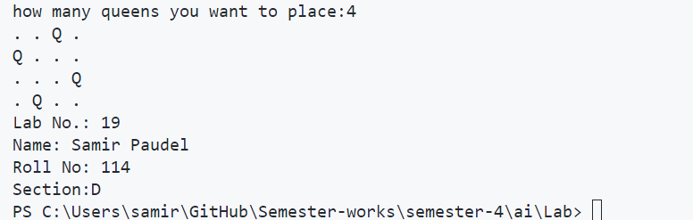

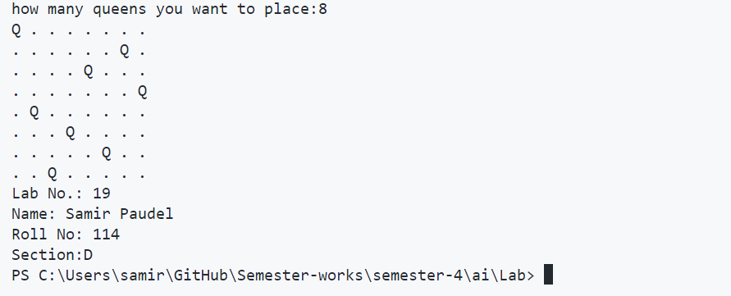

20 | WAP to solve Water Jug Problem.
(Problem statement: Given two jugs, a 4-gallon and 3-gallon having no measuring markers on them. There is a pump that can be used to fill the jugs with water and the water can be poured on the ground. How can you get exactly 2 gallons of water into 4-gallon jug?
Theory:
The water jug problem involves finding a way to measure specific amounts of water using jugs with different capacities. The goal is to reach a specific target amount of water in one of the jugs without exceeding its capacity by transferring water from one jug to another.
The steps or algorithm to solve the water jug problem are as follows:
(i) First, fill the 4-gallon jug completely with water.
(ii) Then, transfer water from the 4-gallon jug to the 3-gallon jug. This leaves 1 gallon of water in the 4-gallon jug.
(iii) Empty the 3-gallon jug.
(iv) Pour the 1 gallon of water from the 4-gallon jug into the 3-gallon jug. Now, the 4-gallon jug is completely empty, and there is 1 gallon of water in the 3-gallon jug.
(v) Refill the 4-gallon jug completely with water.
(vi) Transfer water from the 4-gallon jug to the 3-gallon jug. This leaves 2 gallons of water in the 4-gallon jug, which is the required quantity.
Code:
from collections import deque
def water_jug_bfs(capacity_x, capacity_y, target):
visited = set()
queue = deque([(0, 0, [])])
while queue:
x, y, path = queue.popleft()
if x == target or y == target:
return path + [(x, y)]
if (x, y) in visited:
continue
visited.add((x, y))

# Fill jug X
queue.append((capacity_x, y, path + [(x, y), ('fill X', '')]))
# Fill jug Y
queue.append((x, capacity_y, path + [(x, y), ('fill Y', '')]))
# Empty jug X
queue.append((0, y, path + [(x, y), ('empty X', '')]))
# Empty jug Y
queue.append((x, 0, path + [(x, y), ('empty Y', '')]))

# Pour from X to Y
amount = min(x, capacity_y - y)
queue.append((x - amount, y + amount, path + [(x, y), ('X to Y', f'{amount}')]))
# Pour from Y to X
amount = min(y, capacity_x - x)
queue.append((x + amount, y - amount, path + [(x, y), ('Y to X', f'{amount}')]))
return None

def print_solution(solution):
for i, step in enumerate(solution):
if isinstance(step[0], str):
print(f"Step {i}: {step[0]} {step[1]}")
else:
print(f"State: Jug X = {step[0]}, Jug Y = {step[1]}")

# Solve the Water Jug Problem
capacity_x, capacity_y, target = 4, 3, 2
solution = water_jug_bfs(capacity_x, capacity_y, target)

if solution:
print(f"Solution to get {target} gallons:")
print_solution(solution)
else:
print("No solution found.")
print("Lab No.: 20")
print("Name: Samir Paudel")
print("Roll No: 114")
print("Section:D")

Output:
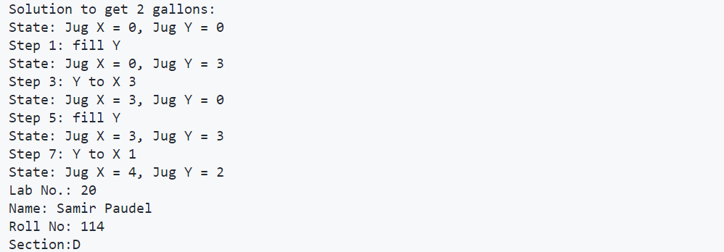

21 | Write a program to demonstrate the steps in genetic algorithm taking suitable example problem.
Theory:
Genetic Algorithms (GAs) are optimization techniques inspired by the process of natural selection. They are used to find approximate solutions to difficult problems by mimicking the process of evolution. GAs work with a population of potential solutions, applying genetic operators like selection, crossover, and mutation to evolve better solutions over generations.
Key components of Genetic Algorithms:
- Population: A set of potential solutions to the problem.
- Fitness function: Evaluates how good a solution is.
- Selection: Choosing individuals for reproduction based on fitness.
- Crossover: Combining genetic information from parents to create offspring.
- Mutation: Random changes in individuals to maintain genetic diversity.
Code:
import random

# Example problem: Maximize f(x) = x^2 where 0 <= x <= 31
# We'll represent x as a 5-bit binary number

def fitness(individual):
x = int(''.join(map(str, individual)), 2)
return x **
def create_individual():
return [random.randint(0, 1) for _ in range(5)]
def create_population(size):
return [create_individual() for _ in range(size)]
def selection(population, k=3):
return max(random.choices(population, k=k), key=fitness)
def crossover(parent1, parent2):
point = random.randint(1, len(parent1) - 1)
child = parent1[:point] + parent2[point:]
return child
def mutation(individual, rate=0.1):
return [bit if random.random() > rate else 1 - bit for bit in individual]
def genetic_algorithm(population_size, generations):
population = create_population(population_size)

for gen in range(generations):
new_population = []

for _ in range(population_size):
parent1 = selection(population)
parent2 = selection(population)
child = crossover(parent1, parent2)
child = mutation(child)
new_population.append(child)

population = new_population
best = max(population, key=fitness)
print(f"Generation {gen+1}: Best = {int(''.join(map(str, best)), 2)}, Fitness = {fitness(best)}")
return max(population, key=fitness)
best_solution = genetic_algorithm(population_size=50, generations=20)
x = int(''.join(map(str, best_solution)), 2)
print(f"nBest solution: x = {x}, f(x) = {x**2}")
print("Lab No.: 21")
print("Name: Samir Paudel")
print("Roll No: 114")
print("Section:D")
Output:
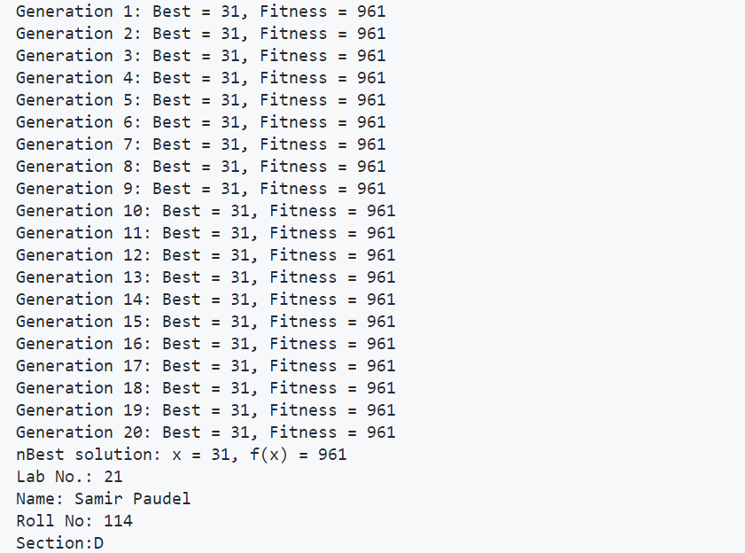

22 | WAP to demonstrate some NLP tasks using NLTK. (Recommended Language : Python)
[Sentence tokenization, Word tokenization, stop words filtering,word stemming, POS tagging, etc.]
Theory:
NLP tasks are a series of steps in the NLP pipeline that help machines read and understand human language.
- Using the NLTK library in Python, we can demonstrate the following natural language processing tasks:
- Sentence tokenization: The sent_tokenize() function is used to split the text into individual sentences.
- Word tokenization: The word_tokenize() function is used to split the text into individual words.
- Stop words filtering: NLTK provides a list of common stop words in different languages. We can use stopwords.words('english') to get a list of English stop words and filter them out from the word tokens.
- Word stemming: The Porter stemming algorithm is used to reduce words to their base or root form. The PorterStemmer() class is used for this purpose.
- Part-of-speech (POS) tagging: The pos_tag() function is used to assign a grammatical tag to each word token.

Code:
import nltk
from nltk.corpus import stopwords
from nltk.tokenize import sent_tokenize, word_tokenize
from nltk.stem import PorterStemmer
from nltk import pos_tag

# Ensure required NLTK resources are available
nltk.download('punkt')
nltk.download('stopwords')
nltk.download('averaged_perceptron_tagger')

# Sample text for NLP tasks
sample_text = "Artificial Intelligence is rapidly transforming various industries, making processes smarter and more efficient."

# Tokenizing sentences
tokenized_sentences = sent_tokenize(sample_text)
print("Sentences after tokenization:")
for sent in tokenized_sentences:
print(sent)

# Tokenizing words
tokenized_words = word_tokenize(sample_text)
print("\nWords after tokenization:")
print(tokenized_words)

# Removing stop words
stop_words_set = set(stopwords.words('english'))
cleaned_words = [w for w in tokenized_words if w.lower() not in stop_words_set]
print("\nWords after removing stop words:")
print(cleaned_words)

# Applying word stemming
stemmer = PorterStemmer()
stemmed_output = [stemmer.stem(w) for w in cleaned_words]
print("\nStemmed words:")
print(stemmed_output)

# Part-of-speech tagging
pos_tagged_words = pos_tag(tokenized_words)
print("\nPOS Tags:")
print(pos_tagged_words)

print("Lab Task: 22")
print("Prepared by: Samir Paudel")
print("Roll Number: 114")
print("Section: D")

Output:
